Enumerators in c

yeh bhi structure or union ki karah khud se data type bana sakate hai

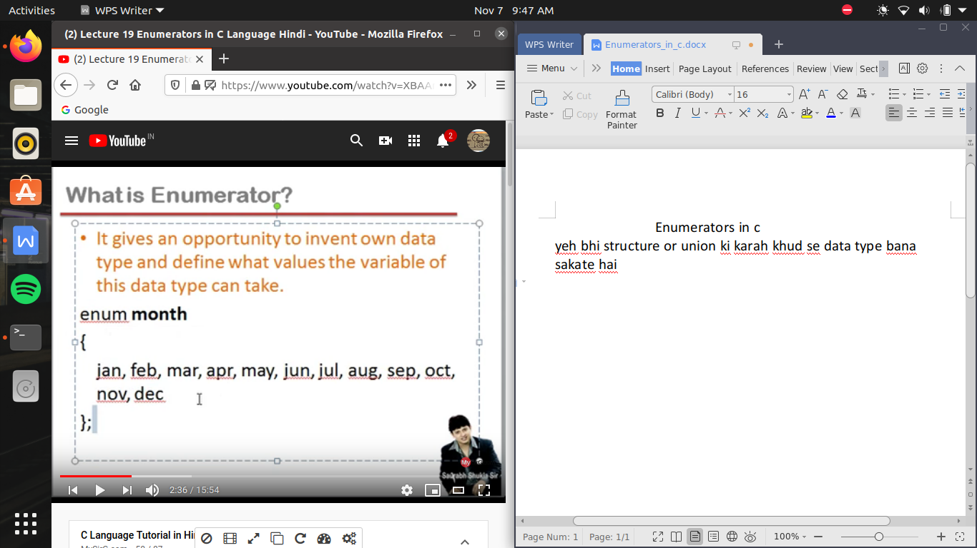

enum <name of data type>

{

<possible list of word which we store in the variable >

these are not variable and separated by comma and no semi colon use not even at the last word

};

and what ever is write in the body of enum , the first word is treat as zero, second word will be 1, by this it will increase in sequence

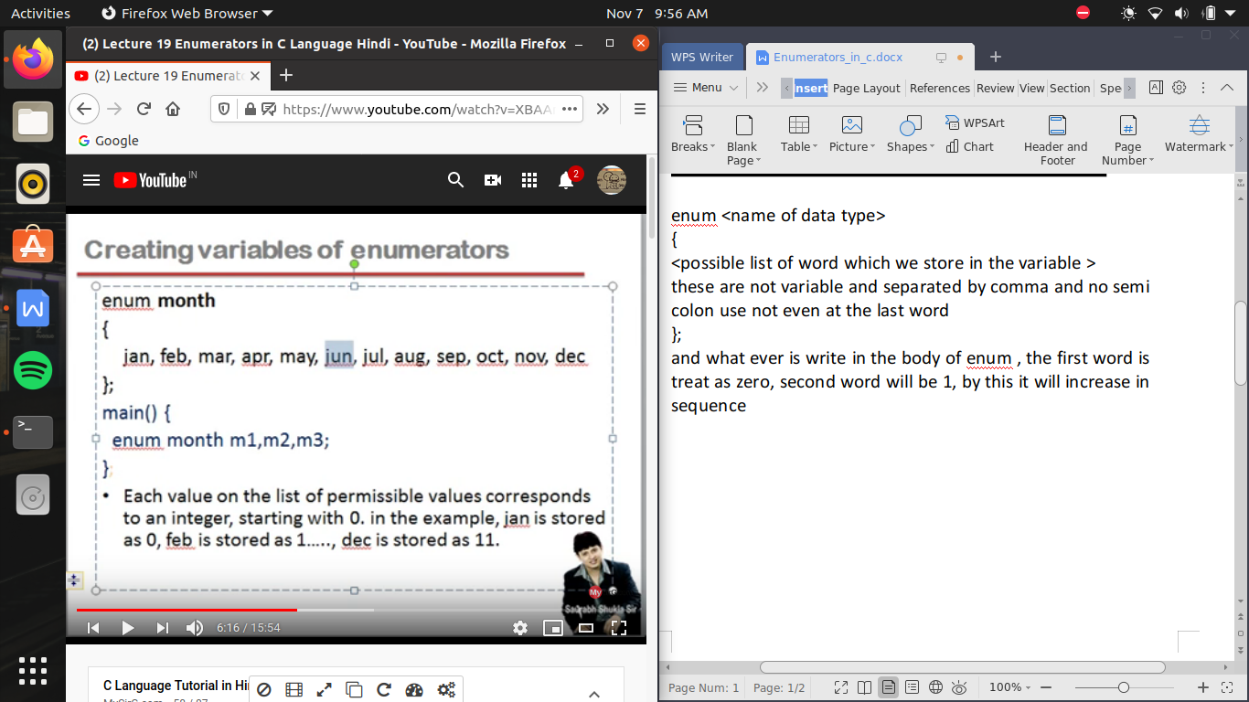

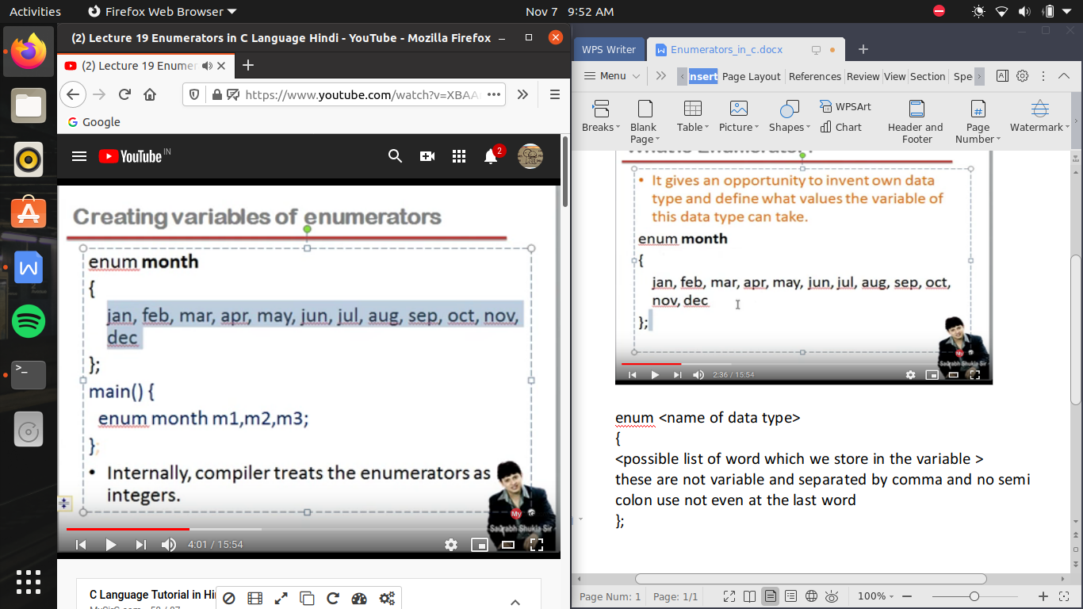

here we can assign directly by

m1=jan;

m2=apr;

es ki jagah ham chahe toh m1= jan ki jagah m1=0 bhi likh sakate hai but es ke program or us ko padana thoda complex ho jata hai ese leye hum nam hi likhate hai jayada tar

#include<stdio.h>

enum boolean //here false =0 and true =1

{

false,true

};

int even_1(int x)

{

if (x%2==0)

return(1);

else

return(0);

}

/* here we can also write the above written program as */

/* by writting as using emulator reablility of program increase */

enum boolean even_2(int x)

{

if (x%2==0)

return(true);

else

return(false);

}

void main()

{

int x,y;

printf("enter a number \n");

scanf("%d",&x);

y=even_1(x);

if (y==1)

printf("even number \n");

else printf("odd number \n");

y=even_2(x);

if(y==true)

printf("even number \n");

else printf("odd number \n");

}

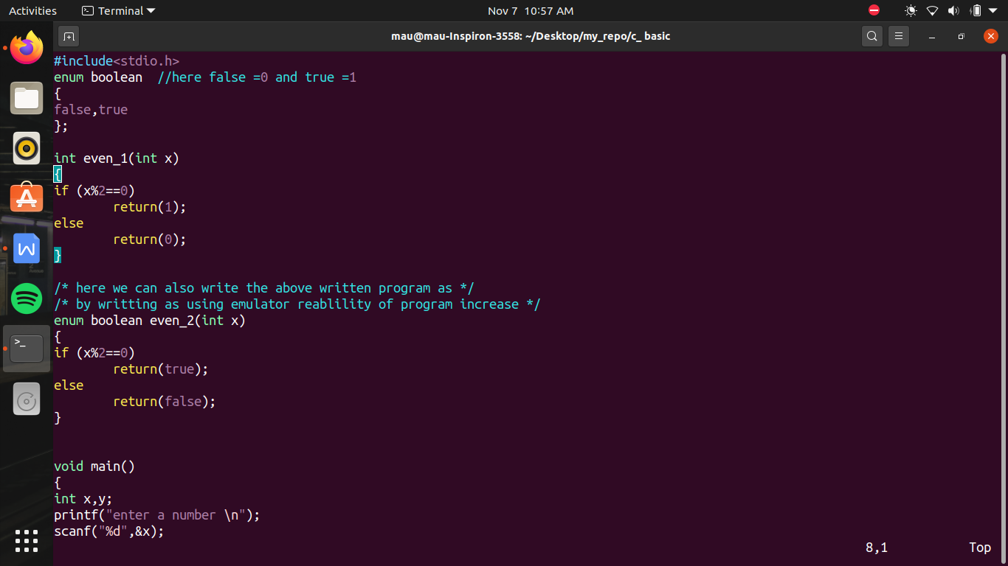

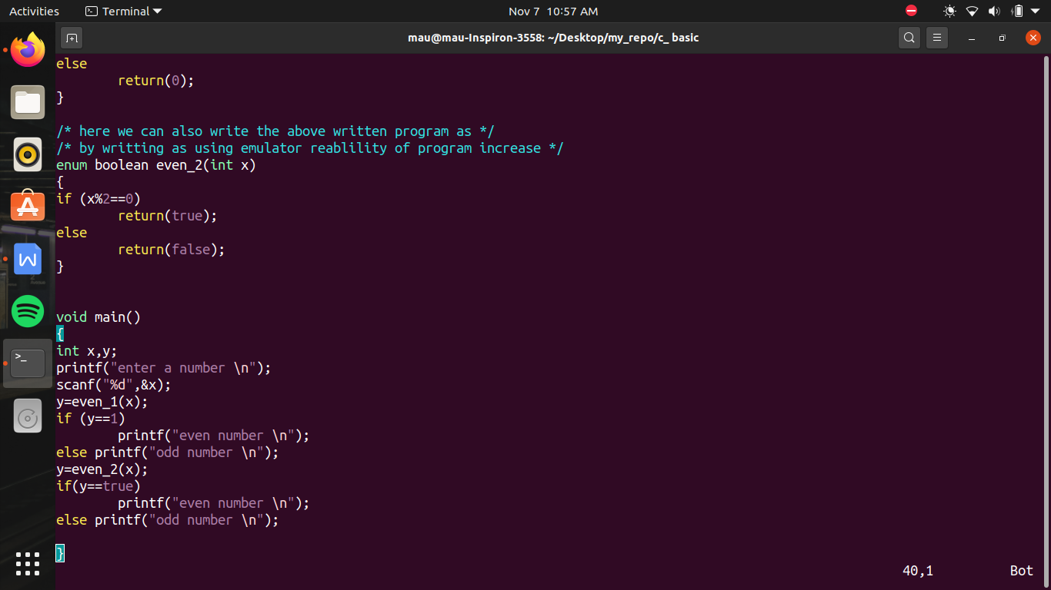

ab jan zero hi kyu agar hame ese change karana hoga toh hum enum body ke andar hum jan ka no. assign kr dege . or agar aisa kr diya toh us ke age ke usi sequence me badege

